**EDUCATIONAL ORGANISATION USING SERVICENOW**

**TEAM ID: NM2025TMID15010**

**TEAM MEMBERS:4**

**TEAM LEADER: BHARATHI.K**

**TEAM MEMBER 1: DHARSHINI.K**

**TEAM MEMBER 2: PRITHIKA.S**

**TEAM MEMBER 3: MEGALA.P**

**PROBLEM STATEMENT:**

Educational institutions today face significant challenges in managing their academic and administrative processes efficiently. The reliance on manual methods for handling student queries, staff requests, and service-related tasks often leads to delays, errors, and a lack of accountability. Miscommunication between students, faculty, and administration further complicates the situation, creating dissatisfaction and inefficiency. Additionally, many existing management systems used in institutions are either fragmented, lacking integration between departments, or too complex and unfriendly for everyday users. As a result, faculty and administrative staff experience an increased workload, while students face slower services and limited transparency.

To overcome these challenges, there is a pressing need for a unified and intelligent digital platform that streamlines operations within educational organizations. Such a system should be capable of automating routine workflows, centralizing different services into a single interface, and providing real-time tracking of requests and resources. By implementing this kind of solution, institutions can improve their operational efficiency, reduce manual errors, and enhance the overall user experience. Ultimately, a centralized digital platform ensures transparency, accountability, and scalability, supporting the long-term goal of digital

**OBJECTIVE:**

The primary objective of this project is to design and implement a digital platform for managing and automating processes in an educational organization using ServiceNow. The project aims to:

* Streamline academic and administrative workflows such as student services, staff requests, and resource management.
* Enhance communication between students, faculty, and administration through a centralized platform.
* Automate routine tasks to reduce manual effort and improve efficiency.
* Provide real-time tracking and reporting of requests, issues, and services.
* Build a scalable and user-friendly system that supports digital transformation in educational organizations.

**TASK INITIATION**

**Activity: Creating an Update Set**

Milestone 1:Update set

Activity:

**Creating a Update Set**

* 1. Navigate to All >> Local update sets .

* 1. Click on new

3.Enter the Details Name: Educational Organisation >> Click on Submit and make Current.

**MILESTONE 2:**

**ACTIVITY:**

**Creating Salesforce Table.**

* Navigate to **All → Tables → New**

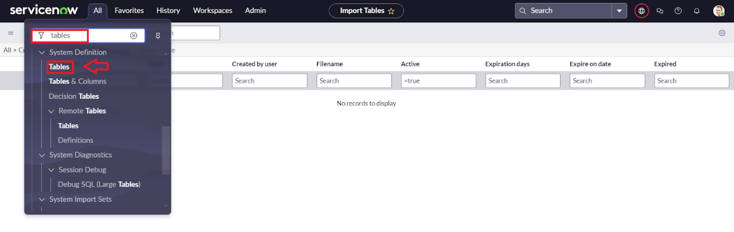

* Click on new

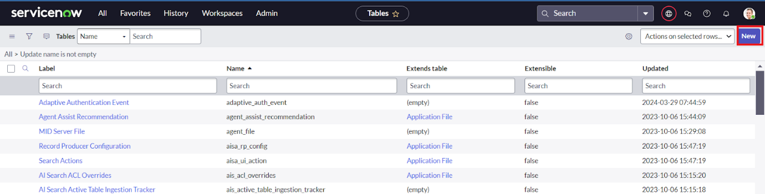

* Enter the Label(Anything you want): Salesforce >> Click on Name it will Automatically generate Api name.

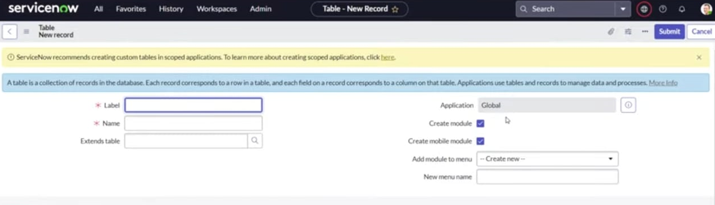

* Create columns as given below,Double Click on Column label and Enter the Column labels and click on the tick mark >> Give Type as given .

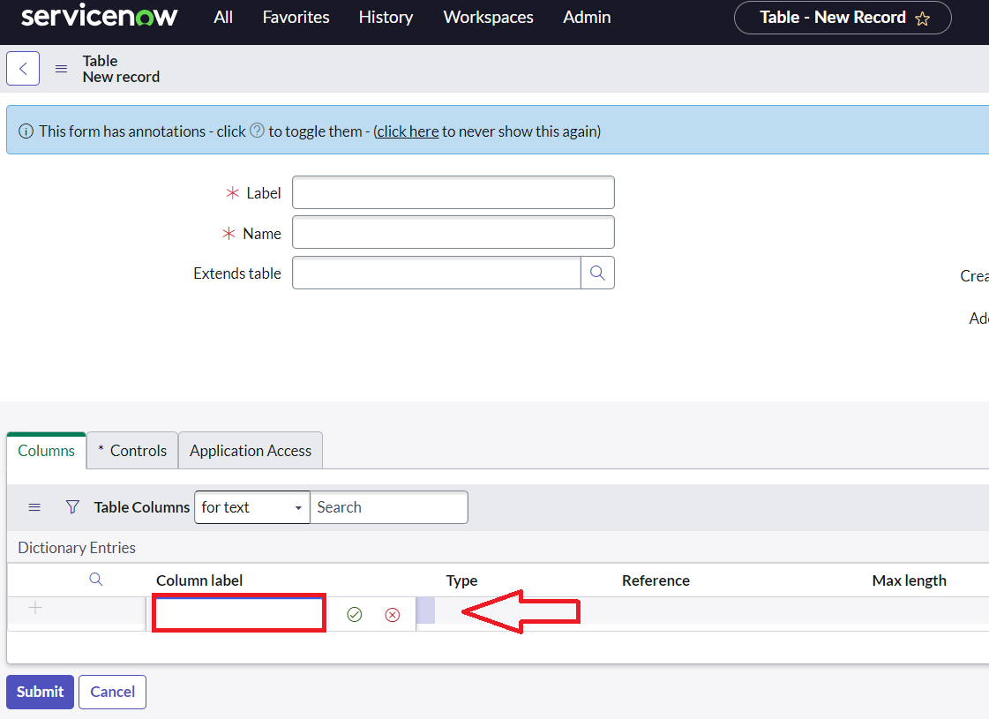x

* For “Admin Number” Give Display as True and right click on the toggle bar on top >> save.

* Click on controls >> Enable Extensible.
* A close-up of a white page

  AI-generated content may be incorrect.
* Click on “Admin Number” column, In Related Links Click on Advanced View >> Default View (Enable Use dynamic default) >> select Get Next Padded Number in Dynamic default value >> Update .

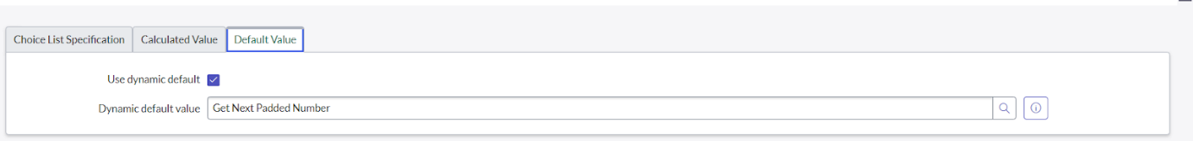

* Click on “Grade” Column >> Click on Choices and give Label,Value and Sequence as given below.

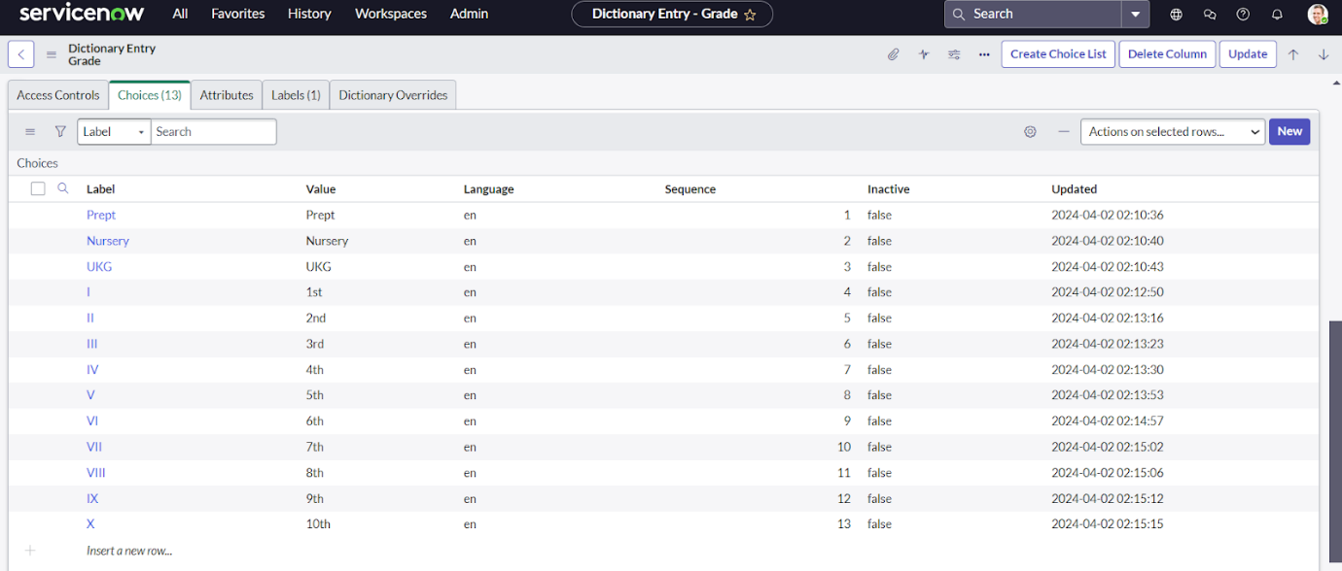

**ACTIVITY:**

**Creating Admission Table**

* Create an Admission Table with Columns given.
* Select Extends Table >> Salesforce and also Select Add module to menu >> Salesforce.
* Create Fields as shown

* Create choice for Admin Status as:

* Create choice for Pincode as:

* Create choice for Purpose of Join as:

* Create choice for School as:

* Create choice for School Area as:

**Activity:Creating Student Progress Table**

* Create a Student Progress Table with Columns given.
* Select Add module to menu >> Salesforce.
* Create Fields as shown:

**MILESTONE 3:Form Layout**

**Activity:Configuring Table form for Student Progress Table**

* In the Student Progress Table Page , Click on Layout form .

* Click on Admission Number [+] .

* Select below Admission Number fields in Available side and send it to selected side as below >> save.

**MILESTONE 4:Form Design**

**Activity:Creating Form Design for Salesforce Table**

1. All >> System Definition >> Tables .
2. In Label Search for Salesforce and open .

1. Right Click on top Toggle >> Configure >> Form Design.

1. In drop down select Salesforce(u_salesforce).

1. Drag and drop the fields to the left side as below.

      6.Save.

**ACTIVITY:**

**Creating Form Design for Admission Table**

Follow the same steps as Activity1,Configure the fields as below and Save.

**ACTIVITY:**

**Creating Form Design for Student progress Table**

Follow the same steps as Activity1,Configure the fields as below and Save.

**MILESTONE 5:Number Maintenance**

**ACTIVITY:**

**Creating Number Maintenance for Admin Number**

* All >> Number Maintenance >> New

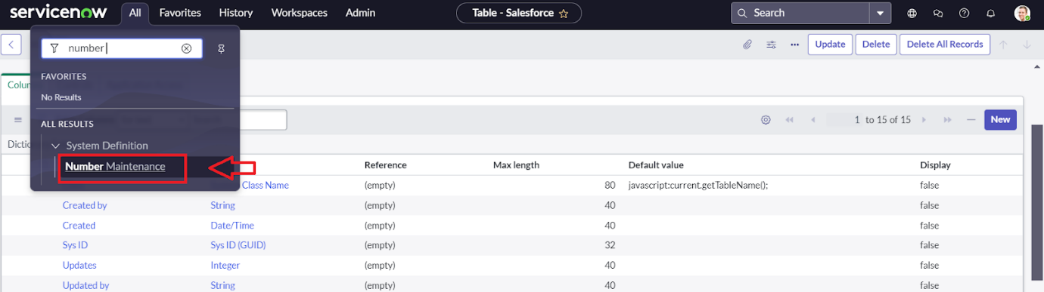

* Fill the details >> Submit.

**MILESTONE 6:Process Flow**

**ACTIVITY:**

**Creating Process Flow for Admission Table**

* All >> Process Flow>> New.
* Fill the Details as given Below

* Right Click on toggle and click on the save .
* Replace the Name and Label as below and click on Insert on stay.A screenshot of a computer

  AI-generated content may be incorrect.
* Replace the Name and Label in order and click on Insert on stay.

Joined >> Rejected >> Rejoined >> Closed >> Cancelled.

* Order should be New >> InProgress >> Joined >> Rejected >> Rejoined >> Closed >> Cancelled.

**MILESTONE 7:Client Script**

**ACTIVITY:**

**Creating “Auto populate” Client Scripts for Admission Table**

* All >> Client Scripts >> New.
* Fill the Details as given.

* Write the Code as below, Enable Isolate script and Save.

function onChange(control, oldValue, newValue, isLoading, isTemplate) {

   if (isLoading || newValue === '') {

      return;

   }

   //Type appropriate comment here, and begin script below

   var a = g_form.getReference('u_admission_number');

   g_form.setValue('u_admin_date',a.u_admin_date);

   g_form.setValue('u_grade',a.u_grade);

   g_form.setValue('u_student_name',a.u_student_name);

   g_form.setValue('u_father_name',a.u_father_name);

   g_form.setValue('u_mother_name',a.u_mother_name);

   g_form.setValue('u_father_cell',a.u_father_cell);

   g_form.setValue('u_mother_cell',a.u_mother_cell);

   g_form.setDisabled('u_admin_date',a.u_admin_date);

   g_form.setDisabled('u_grade',a.u_grade);

   g_form.setDisabled('u_student_name',a.u_student_name);

   g_form.setDisabled('u_father_name',a.u_father_name);

   g_form.setDisabled('u_mother_name',a.u_mother_name);

   g_form.setDisabled('u_father_cell',a.u_father_cell);

   g_form.setDisabled('u_mother_cell',a.u_mother_cell);

}

**Note**: Make sure the Field names should be the same as you created .

**ACTIVITY:**

**Creating “Pincode Update” Client Scripts for Admission Table**

* Fill the Details as given.

* Write the Code as below, Enable Isolate script and Save.

function onChange(control, oldValue, newValue, isLoading, isTemplate) {

   if (isLoading || newValue === '') {

      return;

   }

    var a = g_form.getValue('u_pincode');

if(a == '509358')

{

g_form.setValue('u_mandal', 'kadthal');

g_form.setValue('u_city', 'kadthal');

g_form.setValue('u_district', 'RangaReddy');

}

else if(a == '500081')

{

g_form.setValue('u_mandal', 'karmanghat');

g_form.setValue('u_city', 'karmanghat');

g_form.setValue('u_district', 'RangaReddy');

}

else if(a == '500079')

{

g_form.setValue('u_mandal', 'Abids');

g_form.setValue('u_city', 'AsifNagar');

g_form.setValue('u_district', 'Hyderabad');

}

   //Type appropriate comment here, and begin script below

}

**ACTIVITY:**

**Creating “Disable Fields” Client Scripts for Student progress Table**

* Fill the Details as given.

* Write the Code as below, Enable Isolate script and Save.

function onLoad() {

   //Type appropriate comment here, and begin script below

   g_form.setDisabled('u_total',true);

   g_form.setDisabled('u_percentage',true);

   g_form.setDisabled('u_result',true);

}

**ACTIVITY:**

**Creating “Total Update” Client Scripts for Student progress Table**

* Fill the Details as given.

* Write the Code as below, Enable Isolate script and Save.

function onChange(control, oldValue, newValue, isLoading, isTemplate) {

   if (isLoading || newValue === '') {

      return;

   }

   //Type appropriate comment here, and begin script below

if (newValue){

var a = parseInt(g_form.getValue('u_telugu'));

var b = parseInt(g_form.getValue('u_hindi'));

var c = parseInt(g_form.getValue('u_english'));

var d = parseInt(g_form.getValue('u_maths'));

var e = parseInt(g_form.getValue('u_science'));

var f = parseInt(g_form.getValue('u_social'));

var Total = parseInt(a+b+c+d+e+f);

g_form.setValue('u_total', Total);

}

}

**Activity:**

**Creating “Result” Client Scripts for Student progress Table**

* Fill the Details as given.

* Write the Code as below, Enable Isolate script and Save.

function onChange(control, oldValue, newValue, isLoading, isTemplate) {

   if (isLoading || newValue === '') {

      return;

   }

   //Type appropriate comment here, and begin script below

   if(newValue) {

      var a = parseInt(g_form.getValue('u_percentage')); // Convert the value to an integer for comparison

      if(a >= 0 && a <= 59){

         g_form.setValue('u_result','Fail');

      } else if(a >= 60 && a <= 100) {

         g_form.setValue('u_result','Pass');

      } else {

         // Handle the case if a is out of range (optional)

         g_form.addErrorMessage('Percentage should be between 0 and 100.');

         g_form.clearValue('u_result');

      }

   }

}

**ACTIVITY:**

**Creating “Percentage” Client Scripts for Student progress Table**

* Fill the Details as given.

* Write the Code as below, Enable Isolate script and Save.

function onChange(control, oldValue, newValue, isLoading, isTemplate) {

   if (isLoading || newValue === '') {

      return;

   }

   //Type appropriate comment here, and begin script below

   var Total = g_form.getValue('u_total');

   var Percentage = (Total/600)*100;

   g_form.setValue('u_percentage',Percentage+'%');

}

**RESULT:**

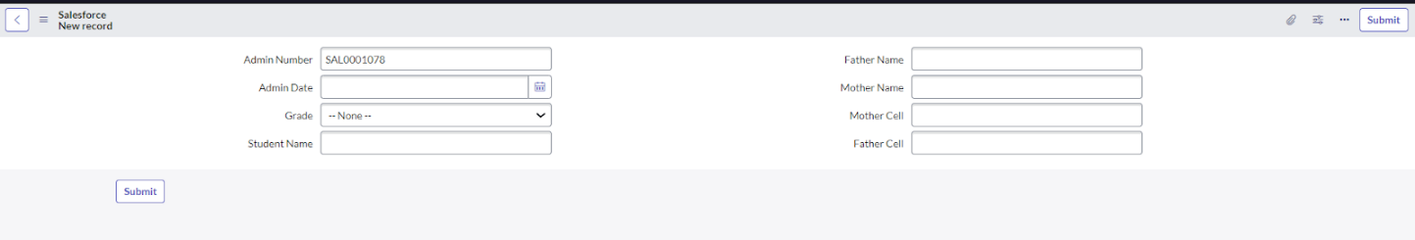

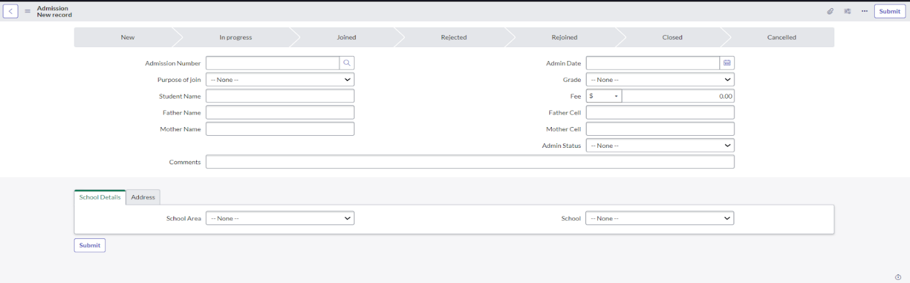

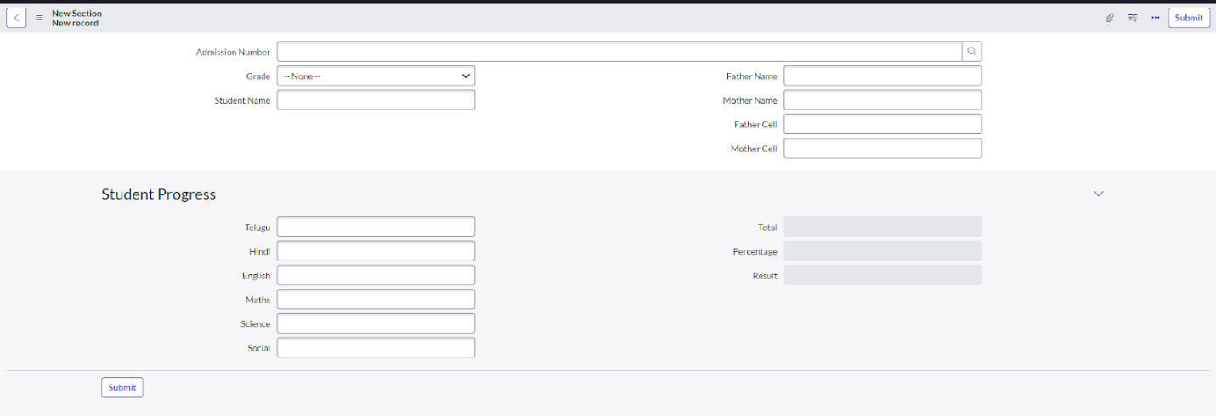

**Conclusion:**  
The project **“Educational Organization using ServiceNow”** successfully demonstrates how digital transformation can streamline educational workflows. By implementing centralized data management, automated workflows, and real-time visibility, the platform enhances communication, reduces delays, and improves user experience.

This ServiceNow-based solution achieves the intended objectives and provides a **scalable, intelligent, and user-friendly system** for educational institutions. The outcome highlights the potential of workflow automation in **academic administration** and sets a foundation for future advancements in digital education management.